**Comcast Section**

When you select NO for auto pay then there should not be a -$10/month discount. Also Modern should be Modem

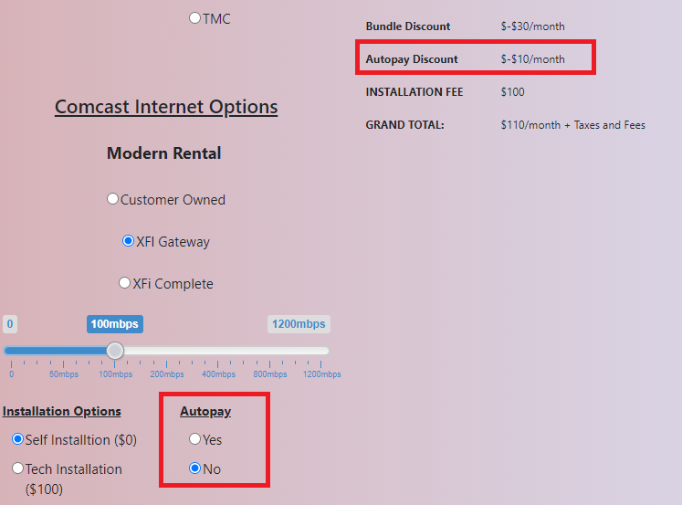

Can this section be Check Boxes. You can have multiple premium options, so we want the ability to check all of them or none of them to add the pricing to the total amount.

